**PROJECT DEVELOPMENT PHASE**

**SPRINT 2: BUZZER**

|  |  |
| --- | --- |
| Date | 17 November 2022 |
| Team ID | PNT2022TMID23566 |
| Project Name | IoT Based Smart Crop Protection System for Agriculture |

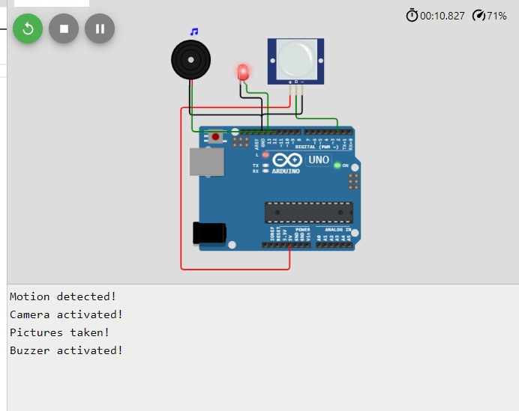

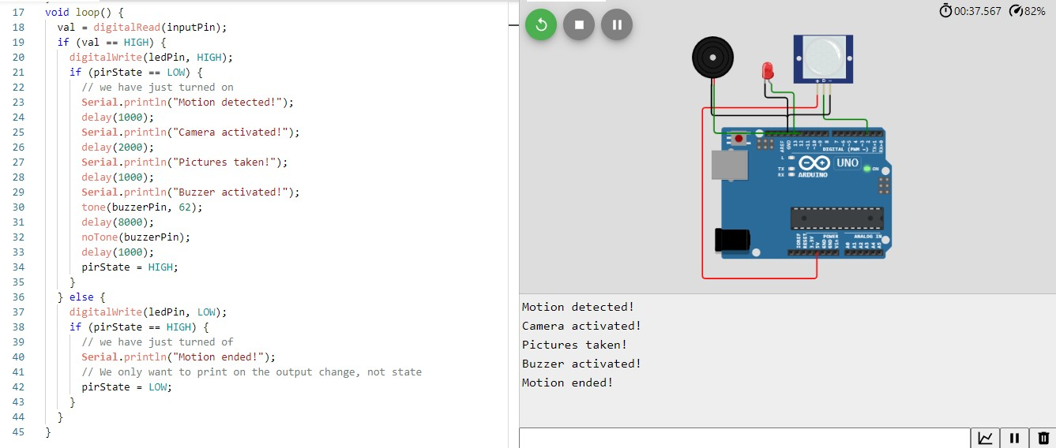

**CODE:**

/*

PIR sensor tester

*/

// LED is considered as the camera in this project.

//It will activated once the movement is detected.

int ledPin = 13; int inputPin = 2; int pirState = LOW; int val = 0; int buzzerPin = 12; void setup() { pinMode(ledPin, OUTPUT); pinMode(buzzerPin, OUTPUT); pinMode(inputPin, INPUT);

**Serial**.begin(9600);

} void loop() { val = digitalRead(inputPin); if (val == HIGH) { digitalWrite(ledPin, HIGH); if (pirState == LOW) {

// we have just turned on

**Serial**.println("Motion detected!"); delay(1000);

**Serial**.println("Camera activated!"); delay(2000);

**Serial**.println("Pictures taken!"); delay(1000);

**Serial**.println("Buzzer activated!"); tone(buzzerPin, 62); delay(8000);

noTone(buzzerPin); delay(1000); pirState = HIGH;

} } else { digitalWrite(ledPin, LOW); if (pirState == HIGH) {

// we have just turned of

**Serial**.println("Motion ended!");

// We only want to print on the output change, not state pirState = LOW;

}

}

}